FPGA Implementation of K-Means Clustering for RGB Video Streams

Overview
This section details the implementation of k-means clustering for RGB video streams using Field Programmable Gate Arrays (FPGAs). The solution is constructed around the Xilinx AXI4 streaming interface, enabling seamless integration into pre-existing image processing pipelines. The main objective is to accelerate image segmentation tasks by exploiting the parallel processing capabilities that FPGAs offer.

Design Approach
The module employs parallel processing techniques to maximize the speed and efficiency of cluster assignment and centroid update operations—both critical components of the k-means clustering algorithm. By optimizing resource allocation and reducing latency, the design capitalizes on the hardware-specific advantages of Xilinx FPGA platforms.

Integration and Compatibility
For wide compatibility and ease of integration, the k-means clustering module features a standard Xilinx AXI4 streaming interface. This design choice allows it to be used as an IP core in diverse image processing workflows and inserted directly into any pipeline that supports AXI4 streaming.

Efficient RGB Stream Segmentation
Leveraging k-means clustering, the module efficiently segments incoming RGB video streams. Hardware-level optimizations ensure that clustering is both rapid and resource-efficient, making the module ideal for real-time image segmentation tasks on FPGA devices.

VHDL Module Interface
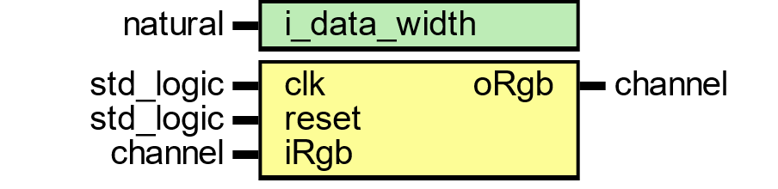
Figure 145 – K-Means Clustering VHDL Module Interface
This figure depicts the entity-level VHDL interface for the k-means clustering module used in RGB video stream segmentation on FPGA. The module is parameterized by i_data_width, which defines the bit width of input pixel data, providing flexibility for different resolutions and precision requirements.
- clk: The system clock input, synchronizing all module operations.
- reset: An asynchronous reset input, responsible for initializing or clearing the module state.
- iRgb: The input stream of RGB pixels, delivered in parallel channels (red, green, blue) with control signals for frame, line, and pixel validity.
- oRgb: The output RGB pixel stream, where each pixel is clustered into its centroid color in RGB space.
This VHDL interface reflects a modular and reusable design, allowing the module to be instantiated as an IP core in larger video pipelines and connected seamlessly to other AXI4-Stream–based modules within a hardware image processing flow.

Module Data Flow and Interface
The k-means clustering module is engineered to process a continuous stream of camera data arranged in a pixel pipeline structure. Input data is provided through dedicated channels for each RGB component: iRgb.red, iRgb.green, and iRgb.blue. Several control signals manage the flow and validity of this data:
- iRgb.valid: Indicates when input pixel data is valid and ready for processing.
- iRgb.eol: Marks the end of a line in the video stream.
- iRgb.eof: Signals the end of a frame.
- iRgb.sof: Denotes the start of a new frame.
After processing through the k-means clustering algorithm, the resulting RGB cluster color space is output via the oRgb channel. This output stream represents the segmented version of the input, with each pixel assigned to its cluster in the RGB color space.

Input RGB Channel Interface
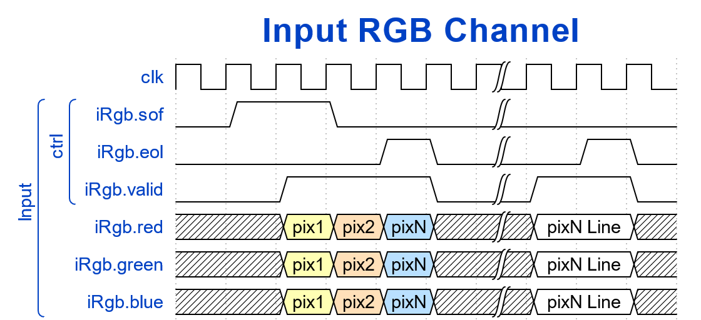
Figure 146
This diagram illustrates the structure of the input RGB video stream to the FPGA-based k-means clustering module. The stream is supplied through three parallel channels: iRgb.red, iRgb.green, and iRgb.blue, each carrying pixel data for its respective color component. Control signals (iRgb.sof, iRgb.eof, iRgb.eol, iRgb.valid) ensure proper pixel synchronization across frames and lines. Each pixel (pix1 to pixN) is aligned in the three channels, forming complete RGB pixels that feed into the clustering engine.

Output RGB Channel Interface
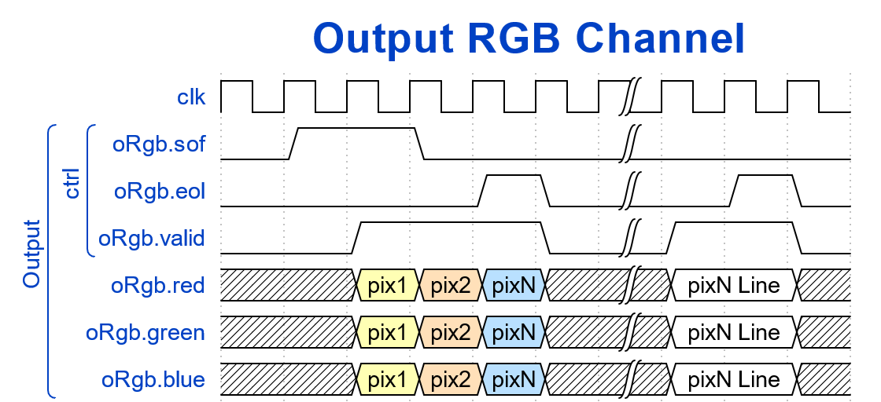
Figure 147
The output RGB stream, following processing by the FPGA’s k-means clustering module, is shown in this diagram. Output channels (oRgb.red, oRgb.green, oRgb.blue) carry cluster-assigned color values, effectively segmenting each video frame into clusters in the RGB color space. Control signals (oRgb.sof, oRgb.eof, oRgb.eol, oRgb.valid) maintain synchronization with the input stream, marking frame boundaries, line terminations, and pixel validity. The result is a continuous, frame-by-frame clustered RGB stream, ideal for real-time display or further downstream video processing.

Implementation and Verification
The k-means clustering module was synthesized and implemented using Vivado 2022.1, targeting the KRIA KV260 board. The entire hardware design and synthesis were carried out to ensure the module's compatibility and optimal performance on this specific FPGA platform.
After completing the hardware design and synthesis, the module underwent thorough verification to validate its correctness and reliability. The verification process was conducted using the ModelSim 2020 edition simulator, which provided a robust environment for simulating and testing the module's functionality. This step was essential to confirm that the implemented design operated as intended and met all specified requirements.
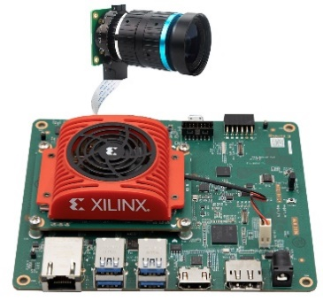
Figure 148

Functional Block Diagram of RGB Data Path to Clustered Conversion
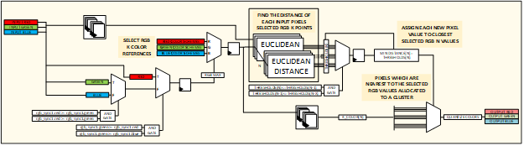
The functional block diagram below illustrates the process of converting RGB input data into clustered output using a k-means-based color quantization algorithm. This module operates directly on the incoming RGB video stream, segmenting pixel data into distinct color clusters for efficient representation and processing.

K-Means Color Quantization Algorithm
The core of this module is the k-means color quantization technique, which is applied to each pixel in the RGB input stream. The process begins by selecting k reference colors in the RGB color space, corresponding to the desired number of clusters. These reference points serve as the basis for grouping similar pixel colors.
For each input pixel, the algorithm calculates its distance from each of the k RGB reference points. This comparison is performed using the Euclidean distance metric, which quantifies the similarity between the pixel’s color values and the reference colors. The pixel is then assigned to the cluster whose reference color is closest, as determined by the minimum calculated distance.

Euclidean Distance Calculation
The Euclidean distance is computed for each pixel by comparing its red, green, and blue components to those of the reference color scheme. The formula used is:
𝐷 = √((RED₂ − RED₁)² + (GREEN₂ − GREEN₁)² + (BLUE₂ − BLUE₁)²)
This calculation ensures that each pixel is grouped with the reference color to which it is most similar.

RGB Color Space and Clustering
Each video frame’s RGB image contains pixel values ranging from 0 to 255 per channel, resulting in a total of 256 × 256 × 256 possible colors. The goal of k-means clustering is to reduce this extensive color space to a manageable set of n clusters, where each cluster represents a group of similar colors. For images with 24-bit color depth, this process compresses the original 16 million possible colors into n representative colors.
The collection of reference colors used in k-means clustering forms the codebook, also known as the color palette or reference color scheme. After clustering, each pixel in the image is mapped to one of these n colors, effectively quantizing the image and simplifying its color representation.

Module Interface
The k-means clustering module includes clock and reset ports for proper operation. Data interfaces consist of iRGB and oRGB ports, each comprising separate red, green, and blue channels. A valid signal accompanies these channels to ensure synchronization and correct data handling throughout the clustering process.

